Introduction

This project is designed to automate the process of booking a venue for the event, managing the whole process online. It will help in managing events on both small and large scales like conferences, weddings, festivals, formal parties, gatherings, get-together, etc.

Event management is a process of organizing a professional and focused event, for particular target audience. It involves visualizing concepts, planning, budgeting, organizing and executing events such as fashion shows, musical concerts, corporate seminars, exhibitions,wedding celebrations, theme parties, product launching etc.

In the dynamic landscape of today's technology-driven world, efficient event management stands as a pivotal element for successful gatherings, conferences, and celebrations. The ability to seamlessly coordinate and organize events has become a critical aspect of various industries, ranging from business conferences to social functions. This project report delves into the realm of event management, employing the powerful combination of Spring Boot, JavaServer Pages (JSP), and MySQL to create a robust and scalable solution.

Spring Boot, with its simplified configuration and convention over configuration paradigm, has emerged as a popular framework for developing Java-based web applications. JSP, providing a powerful and dynamic template engine for building user interfaces in Java applications, complements Spring Boot's capabilities. Furthermore, MySQL, a widely-used relational database management system, becomes a pivotal component to ensure secure, scalable, and efficient storage and retrieval of event-related data.

This project aims to provide a comprehensive understanding of the integration of Spring Boot, JSP, and MySQL in the context of event management. We explore the key components of event management systems, including user registration, event creation, attendee management, and real-time updates. By leveraging the strengths of Spring Boot's dependency injection, MVC architecture, JSP's dynamic content generation, and MySQL's robust database capabilities, we strive to create a seamless and intuitive user experience.

Throughout this report, we will discuss the design principles, implementation details, and challenges encountered in building an event management system using Spring Boot, JSP, and MySQL. Emphasis will be placed on the integration of these technologies, ensuring data consistency, reliability, and efficient management within the MySQL database.

As we embark on this exploration, our goal is to present a valuable resource for developers, businesses, and enthusiasts interested in harnessing the combined power of Spring Boot, JSP, and MySQL to create sophisticated and efficient event management systems. Through the integration of cutting-edge technologies and best practices, this project aims to contribute to the ever-evolving field of event management, providing insights that empower the development of innovative and seamless solutions for a diverse range of events.

PROBLEM DEFINITION
These days the world has become a digital world where everything is available in a single click or touch. The definition of our problem lies in manual system and a fully automated system of Event Management System .

Manual system:
In Manual system is more prone to errors and sometimes it encounters various problems which are unstructured. Because things are managing by the human on the paper there might high chances to get mistakes as well as its time consuming and high money consuming.

Technical system:
The technical system comes with the advent of latest technology and user can access the application over the browser and Check the car and manage the things in just few clicks.

In the realm of event management, there exists a pressing need for a robust and scalable solution that seamlessly integrates user interaction, dynamic content generation, and efficient data storage. Traditional approaches often face challenges in terms of complexity, maintainability, and adaptability to evolving requirements. Recognizing these limitations, the aim of this project is to address the following key problems in the context of event management:

Inefficient User Interaction:

Current event management systems often struggle to provide an intuitive and user-friendly interface for both event organizers and attendees. Navigating through the registration process, event creation, and attendee management can be cumbersome, leading to a suboptimal user experience.

Limited Scalability:

Many existing solutions encounter scalability issues, especially as the number of events and attendees grows. Scalability is a crucial aspect, and systems may face performance bottlenecks when handling a large volume of concurrent users, impacting the responsiveness and overall efficiency.

Data Management Challenges:

Effective management of event-related data, including user profiles, event details, and attendee information, is paramount. Traditional databases may struggle to provide the necessary speed and reliability required for real-time updates, leading to potential inconsistencies and delays in data retrieval.

Integration Complexity:

Integrating different technologies and frameworks to create a cohesive and efficient event management system can be complex. Ensuring seamless communication between Spring Boot, JSP, and the underlying MySQL database poses challenges in terms of configuration, compatibility, and maintaining a coherent development workflow.

Security Concerns:

Security is a critical aspect, especially when dealing with user data and sensitive information. Traditional systems may lack robust security measures, exposing vulnerabilities that could compromise the integrity of the system and user privacy.

This project seeks to tackle these challenges by leveraging the strengths of Spring Boot, JSP, and MySQL. By providing an integrated solution that addresses the inefficiencies in user interaction, scalability, data management, integration complexity, and security concerns, we aim to contribute to the development of a cutting-edge event management system that meets the demands of modern applications and user expectations.

OBJECTIVES
To develop a system to Event Management, this will perform all the Event Management operation on an online platform. A system that has good management of data along with integrity and minimizing redundancy.

Seamless User Experience:

Create an event management system that offers an intuitive and user-friendly interface for both event organizers and attendees. Streamline processes such as user registration, event creation, and attendee management to enhance the overall user experience.

Scalability and Performance:
Develop a scalable solution capable of handling a large volume of events and concurrent users without compromising performance. Implement optimization techniques to ensure responsiveness and efficiency as the system grows in both user base and event count.

Efficient Data Management:
Design and implement a robust data management strategy leveraging the MySQL database. Ensure efficient storage, retrieval, and real-time updates of event-related data, including user profiles, event details, and attendee information.

Seamless Integration of Technologies:
Integrate Spring Boot, JSP, and MySQL seamlessly to create a cohesive and efficient event management system. Address challenges related to configuration, compatibility, and workflow to establish a smooth interaction between these technologies.

Enhanced Security Measures:
Implement robust security measures to safeguard user data and ensure the integrity of the event management system. Employ encryption, authentication, and authorization mechanisms to mitigate potential security threats and protect user privacy.

Modular and Maintainable Architecture:
Design a modular and maintainable architecture for the event management system, adhering to best practices and design principles. Facilitate future enhancements and modifications while minimizing the impact on existing functionality.

Real-time Updates and Notifications:
Incorporate real-time updates and notification features to keep event organizers and attendees informed of any changes or updates related to the events. Implement mechanisms for instant communication and notifications within the system.

Comprehensive Documentation:
Provide comprehensive documentation covering the design, implementation, and usage of the event management system. Ensure that developers, administrators, and other stakeholders can easily understand and work with the system.

User and System Analytics:
Integrate analytics features to track user interactions and system performance. Collect data on user engagement, popular events, and system usage patterns to inform future enhancements and optimizations.

User Feedback and Iterative Improvement:
Establish a mechanism for collecting user feedback and continuously iterate on the system based on user suggestions and emerging requirements. Foster a user-centric development approach to enhance the system's usability and effectiveness over time.

USED TOOLS AND TECHNOLOGIES
We have a wide range of options of programming languages. From these options we can choose appropriate platform tools, technologies and languages for development of the airline reservation project.

Some of these are as following

Programming Languages: Java.

Relational Database: MYSQL.

SOFTWARE REQUIREMENTS:

Operating system : Windows Family
Front End : CSS, JSP, HTML
Back End : Spring boot, Hibernate, JPA.
Server : Tomcat Server

HARDWARE SPECIFICATIONS

Processor : (i5) Intel Pentium or more
Ram : 8 GB
Hard disk : 50 GB hard disk recommended

SOFTWARE ENGINEERING APPROACH
The field of software engineering is related to the development software in systematic manner unlike simple programs which can be developed in isolation and there may not be any systematic approach being followed. there is a big difference between programming and software engineering process. As it provides models that lead to the production of well documented software in a manner that is predictable.

For a planning process, it should be possible to determine in advance the time and effort will be required to develop the final product.

The model I have used is Waterfall Model or Classic Life Cycle. In this model first of all the existed system is observed. Then customer requirements are taken in consideration then planning, modeling, construction and finally deployment.

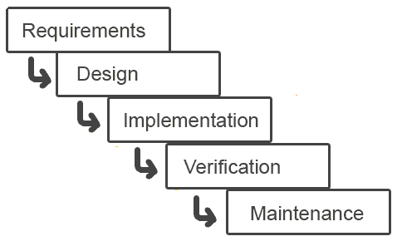
ANALYSIS & SYSTEM DESIGN

Requirement Analysis collects data through interviews, questionnaires, on-site observations, and procedural manuals and like. It is required to organize and convert the data through system flowcharts, data flow diagrams, structured decision tables and the like that support future development of the system.

The Data flow diagrams and various processing logic techniques show how, where, and when data are used or changed in an information system, but these techniques do not show the definition, structure and relationships within the data.

It is a way to focus on functions rather than the physical implementation. This is analogous to the architect’s blueprint as a starting point for system design. The design is a solution, a “how to” approach, compared to analysis, a “what is” orientation.

System design is a highly creative process. This system design process is also referred as data modeling. The most common formatted used the E-R notation explains the characteristics and structure of data independent of how the data may be stored in computer memories.

The process of system design can be divided into three stages. They are two
Structure design

- Database design
- Interface design

- As we know that system design is a solution to “How to approach to the creation of new system”. It provides the understudying and procedural details necessary for implementing the system. The steps involved during system design were as follow
DFD for Event Management System

- First Level of Data Flow Diagram for Admi

Second Level of Data Flow Diagram for User
UML Diagrams
DFD diagrams:

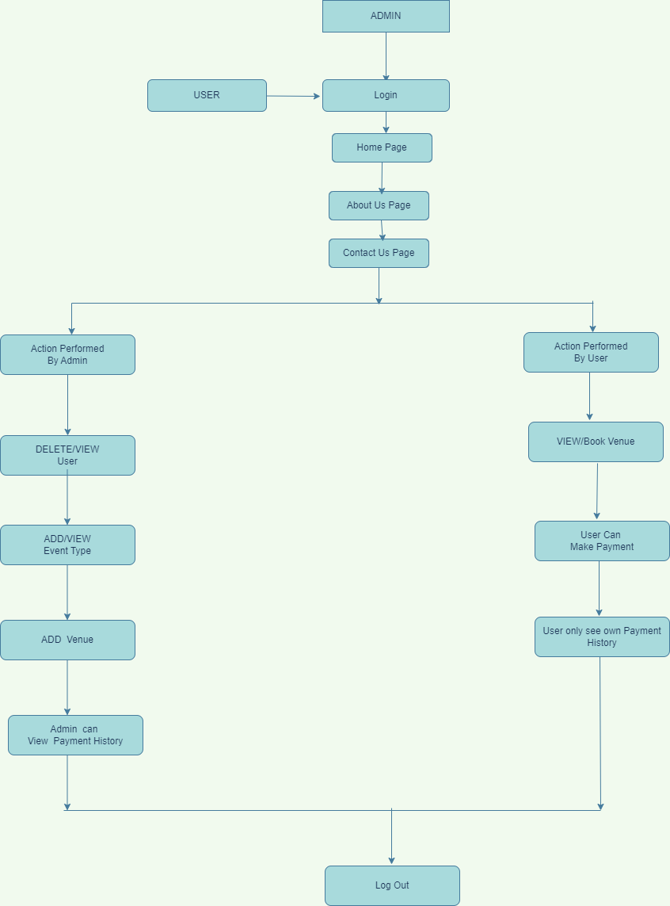

- R Diagram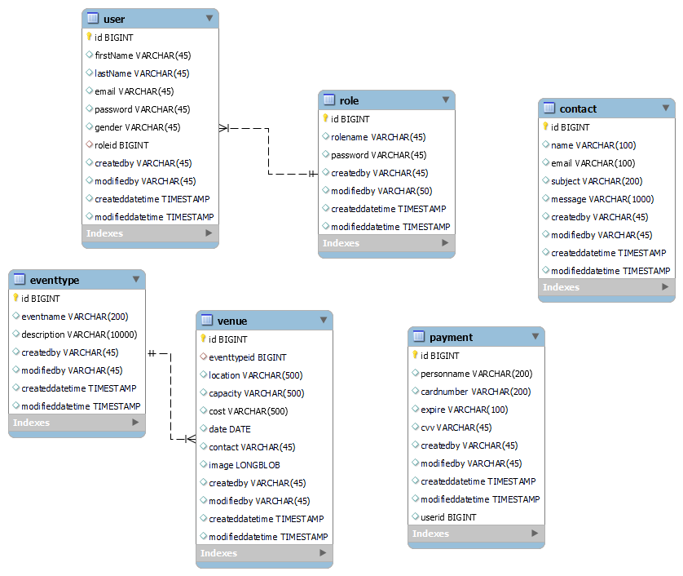

LOGICAL AND PHYSICAL DESIGN
In the current physical system is thoroughly reviewed from point of view like how the data flow, what are file contents, its volumes, complexity and frequency etc.

After this input, output specifications security and control specification is prepare. It was also decided that how physical data information will flow through the system and a physical design walk through.

OUTPUT DESIGN
- The format of outputs is designed in user-friendly way that it is simple to read and interpret in the present output we have clearly labeled title, messages it contains date and time and all the fields are clearly mentioned as placeholders or label.
Screen Short And Source Code

Please ADD the latest updated Screenshots and Source code after project configuration.
ADD Updated Source code
TESTING
Software Testing
Software testing is a process of verifying and validating that a software application or program.

Meets the business and technical requirements that guided its design and development, and Works as expected.

Software testing also identifies important defects, flaws, or errors in the application code that must be fixed. The modifier “important” in the previous sentence is, well, important because defects must be categorized by severity.

During test planning we decide what an important defect is by reviewing the requirements and design documents with an eye towards answering the question “Important to whom?” Generally speaking, an important defect is one that from the customer’s perspective affects the usability or functionality of the application.

The quality assurance aspect of software development documenting the degree to which the developers followed corporate standard processes or best practices is not addressed in this paper because assuring quality is not a responsibility of the testing team.

The testing team cannot improve quality they can only measure it, although it can be argued that doing things like designing tests before coding begins will improve quality because the coders can then use that information while thinking about their designs and during coding and debugging.

Software testing has three main purposes: verification, validation, and defect finding.

The verification process confirms that the software meets its technical specifications. A “specification” is a description of a function in terms of a measurable output value given a specific input value under specific preconditions.
A simple specification may be along the line of “a SQL query retrieving data for a single account against the multi-month account-summary table must return these eight fields <list> ordered by month within 3 seconds of submission.”

The validation process confirms that the software meets the business requirements. A simple example of a business requirement is “After choosing a branch office name, information about the branch’s customer account managers will appear in a new window. The window will present manager identification and summary information about each manager’s customer base: <list of data elements>.”

Other requirements provide details on how the data will be summarized, formatted and displayed.

A defect is a variance between the expected and actual result. The defect’s ultimate source may be traced to a fault introduced in the specification, design, or development (coding) phases.

Testing methods
Software testing methods are traditionally divided into black box testing and white box testing. These two approaches are used to describe the point of view that a test engineer takes when designing test cases.

Black box testing
Black box testing treats the software as a "black box"—without any knowledge of internal implementation. Black box testing methods include: equivalence partitioning, boundary value analysis, all-pairs testing, fuzz testing, model-based testing, traceability matrix, exploratory testing and specification-based testing.

Specification-based testing: Specification-based testing aims to test the functionality of software according to the applicable requirements. Thus, the tester inputs data into, and only sees the output from, the test object. This level of testing usually requires thorough test cases to be provided to the tester, who then can simply verify that for a given input, the output value (or behavior), either "is" or "is not" the same as the expected value specified in the test case.
Specification-based testing is necessary, but it is insufficient to guard against certain risks.

Advantages and disadvantages:
The black box tester has no "bonds" with the code, and a tester's perception is very simple: a code must have bugs. Using the principle, "Ask and you shall receive," black box testers find bugs where programmers do not.

But, on the other hand, black box testing has been said to be "like a walk in a dark labyrinth without a flashlight," because the tester doesn't know how the software being tested was actually constructed.

As a result, there are situations when 1 a tester writes many test cases to check something that could have been tested by only one test case, and/or 2 some parts of the back-end are not tested at all.

Therefore, black box testing has the advantage of "an unaffiliated opinion," on the one hand, and the disadvantage of "blind exploring," on the other.

White box testing
White box testing is when the tester has access to the internal data structures and algorithms including the code that implement these.

Types of white box testing

API testing (application programming interface) - Testing of the application using Public and Private APIs

Code coverage - creating tests to satisfy some criteria of code coverage (e.g., the test designer can create tests to cause all statements in the program to be executed at least once)
Fault injection methods - improving the coverage of a test by introducing faults to test code paths

Mutation testing methods

Static testing White box testing includes all static testing

A sample testing life cycle

Although variations exist between organizations, there is a typical cycle for testing:

Requirements analysis: Testing should begin in the requirements phase of the software development life cycle. During the design phase, testers work with developers in determining what aspects of a design are testable and with what parameters those tests work.

Test planning: Test strategy, test plan, tested creation. Since many activities will be carried out during testing, a plan is needed.

Test development: Test procedures, test scenarios, test cases, test datasets, test scripts to use in testing software.

Test execution: Testers execute the software based on the plans and tests and report any errors found to the development team.

Test reporting: Once testing is completed, testers generate metrics and make final reports on their test effort and whether or not the software tested is ready for release.

Test result analysis: Or Defect Analysis, is done by the development team usually along with the client, in order to decide what defects should be treated, fixed, rejected (i.e. found software working properly) or deferred to be dealt with later.

Defect Retesting: Once a defect has been dealt with by the development team, it is retested by the testing team.

Regression testing: It is common to have a small test program built of a subset of tests, for each integration of new, modified, or fixed software, in order to ensure that the latest delivery has not ruined anything, and that the software product as a whole is still working correctly.

Test Closure: Once the test meets the exit criteria, the activities such as capturing the key outputs, lessons learned, results, logs, documents related to the project are archived and used as a reference for future projects.

Conclusion

Event Management System is user friendly and cost effective system, it is customized with activities related to event management life-cycle.

It provides a new edge to management industry. SolutionDot always keep your objectives and goals on top priority while developing any plan of work.

In this project, we made attempt to effectively introduce the concept of event management systems already existing in the society. We then explain the concept of online event management systems which are already present. We describe the proposed system and explain the features implemented by our proposed system .We also give a brief overview of the technologies used during the development of our proposed system. This project can be further refined and extended by introducing new and more innovative features.

